Dokumentacja platformy – format źródłowy epCollXML
epodreczniki.pl

Wprowadzenie
Platforma epodreczniki.pl jest oparta na standardach open source, w szczególności na standardzie XML. Jest to powszechnie stosowany język, używany do tworzenia ustrukturalizowanych zbiorów danych na podstawie reguł semantycznych. W projekcie epodreczniki.pl jest on używany do tworzenia i edytowania e-
podreczników. Do tego celu został zaadaptowany i rozszerzony schemat XML zaproponowany przez projekt Connexions: CNXML, CollXML, mdml, QML and BibTeXML.

Schemat Connexions został stworzony w formacie RNG. Na potrzeby epodreczniki.pl został on skonwertowany do formatu XSD, pozwalającym wyrazić potrzebne reguły i wymagania.

W rezultacie postały nowe schematy XML:

- epCollXML

- epXML

epCollXML

epCollXML jest formatem zapisu reprezentującym jeden e-podręcznik. Składa się z zestawu metadanych opisujących właściwości podręcznika oraz kolekcji modułów zawierających właściwą treść e-podręcznika. Każdy moduł jest oddzielnym jednostką zawierającą treść w formacie epXML.

epCollXML definiuje strukturę e-podręcznika, łącznie z opcjonalnymi podkolekcjami (subcollections) modułów i ich kolejnością.

Schematy

Elementem głównym każdej kolekcji epCollXML jest element col:collection. Zawiera 2 podstawowe elementy podrzędne col:metadata i col:content.

Metadane specyficzne dla formatu epCollXML (nowe względem Connexions) są zawarte w podelemencie col:metadata: ep:e-textbook.
Element col:content zawiera hierarchię elementów col:module, które mogą być grupowane w opcjonalnych elementach col:subcollection.

Przykładowy epCollXML
<?xml version="1.0" encoding="utf-8"?>
<col:collection xmlns:col="http://cnx.rice.edu/collxml" xmlns:ep="http://epodreczniki.pl/" xmlns:md=http://cnx.rice.edu/mdml xmlns:cnxsi="http://cnx.rice.edu/system-info">

<col:metadata mdml-version="0.5">

<md:content-id>321</md:content-id>

<md:repository>https://rep.epodreczniki.pl/repo</md:repository>

<md:version>1</md:version>

<md:created>2013-08-27 03:35 CEST</md:created>

<md:revised>2014-05-12 10:13 CEST</md:revised>

<md:language>pl</md:language>

<md:license url="http://www.example.com/license"/>

<md:title>Matematyka 1. Gimnazjum</md:title>

<md:education-levellist>
<md:education-level key="E3">Gimnazjum</md:education-level>

</md:education-levellist>

<md:subjectlist>
<md:subject>matematyka</md:subject>

</md:subjectlist>
<md:abstract>Abstrakt e-podręcznika</md:abstract>

<ep:e-textbook ep:version="1.5" ep:content-status="canon" ep:recipient="student">

<ep:references>

<ep:collection-header>
<ep:reference ep:id="KOD_WOMI1"/>

</ep:collection-header>

</ep:references>
<ep:class>1</ep:class>

<ep:cover ep:cover-type="png">123</ep:cover>

<ep:signature/>
<ep:show-technical-remarks>false</ep:show-technical-remarks>

<ep:learning-objectives>

<ep:learning-objective>
<ep:learning-objective-version ep:key="1.1">Dz.U. 30.05.2014, poz. 803</ep:learning-objective-version>

<ep:learning-objective-stage ep:key="E4">Etap 1</ep:learning-
objective-stage>
<ep:learning-objective-school ep:key="SRE">Szkoły
ponadgimnazjalne, których ukończenie umożliwia uzyskanie świadectwa dojrzałości po zdaniu egzaminu maturalnego</ep:learning-objective-school>

<ep:learning-objective-subject ep:key="MAT">Matematyka</ep:learning-objective-subject>

<ep:learning-objective-scope ep:key="I">Zakres podstawowy</ep:learning-objective-scope>

<ep:learning-objective-name ep:key="CEL-E4-SRE-MAT-1.0-I- I">Wykorzystanie i tworzenie informacji</ep:learning-objective-name>

<ep:learning-objective-text>Uczeń interpretuje tekst matematyczny. Po rozwiązaniu zadania interpretuje otrzymany wynik.</ep:learning- objective-text>

</ep:learning-objective>

</ep:learning-objectives>

</ep:e-textbook>

<md:actors>
<md:person userid="1">

<md:fullname>Jan Kowalski</md:fullname>

<md:firstname>Jan</md:firstname>

<md:surname>Kowalski</md:surname>

<md:email>jan.kowalskie@example.com</md:email>

</md:person>

</md:actors>

<md:roles>
<md:role type="author">1</md:role>

</col:metadata>

<col:content>
<col:module cnxsi:version-at-this-collection-version="11" document="izpMGjkRLH" repository="http://rep.epodreczniki.pl/module/ version="11">

<md:title>Strona do pominięcia w spisie</md:title>
</col:module>

<col:subcollection>

<ep:view-attributes>
<ep:view-attribute ep:type="panorama" ep:id="1009"/>

</ep:view-attributes>
<md:title>Tytuł rozdziału</md:title>

<col:content>
<col:module cnxsi:version-at-this-collection-version="14" document="i7cNQ1OanJ" repository="http://rep.epodreczniki.pl/module/" version="14">

<md:title>Pojęcie funkcji</md:title>

</col:module>
<col:module cnxsi:version-at-this-collection-version="13" document="iTo6Ej1mUI" repository="http://rep.epodreczniki.pl/module/" version="13">

<md:title>Dziedzina funkcji</md:title>

</col:module>
<col:module cnxsi:version-at-this-collection-version="10" document="iMe73KkQt8" repository="http://rep.epodreczniki.pl/module/" version="10">

<md:title>Argument i wartość funkcji. Miejsca zerowe funkcji liczbowej</md:title>

</col:module>

</col:content>

</col:subcollection>

</col:content>

</col:collection>
Schema collxml.xsd

schema location: | collxml.xsd
attributeFormDefault:
elementFormDefault: | qualified
targetNamespace: | http://cnx.rice.edu/collxml

Elements
collection
content
metadata
module
subcollection

schema location: | mdml.xsd
attributeFormDefault:
elementFormDefault: | qualified
targetNamespace: | http://cnx.rice.edu/mdml

Elements
abstract
actors
content-id
content-url
created
education-levellist
keywordlist
language
license
organization
person
repository
revised
role
roles
subjectlist
subtitle
title
version
schema location: |  | ep.xsd
attributeFormDefault:
elementFormDefault: |  | qualified
targetNamespace: |  | http://epodreczniki.pl/

Elements | Complex types | Attributes | Attr. groups
collection-header | type-link-reference | id | group-attr-status-and-recipient
cover |  | numbering
e-textbook |  | toc
editor
learning-objectives
origin-id
origin-version
references
root-id
view-attributes

schema location: | cnxsi.xsd
attributeFormDefault:
elementFormDefault: | qualified
targetNamespace: | http://cnx.rice.edu/system-info

Attributes
version-at-this-collection-version

schema location: | common.xsd
attributeFormDefault:
elementFormDefault: | qualified
targetNamespace: | http://cnx.rice.edu/mdml

Complex types | Simple types
type-elem-string-attr-key | type-not-empty-positive-integer
type-elem-string-attr-key-qualified | type-not-empty-string
 | type-string-min-lenght-one
 | type-string-skip-include

schema location: | common.xsd
attributeFormDefault:
elementFormDefault: | qualified
targetNamespace: | http://epodreczniki.pl/

Complex types | Simple types
type-elem-string-attr-key | type-not-empty-positive-integer
type-elem-string-attr-key-qualified | type-not-empty-string

type-string-min-lenght-one
type-string-skip-include

element collection
diagram | 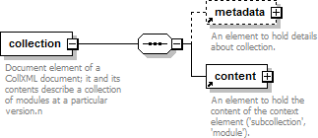
namespace | http://cnx.rice.edu/collxml
properties | content complex
children | metadata content
annotation | documentation  Document element of a CollXML document; it and its contents describe a collection of modules at a particular version.n
source | <xs:element name="collection">  <xs:annotation>  <xs:documentation>Document element of a CollXML document; it and its contents describe a collection of modules at a particular version.n</xs:documentation>  </xs:annotation>  <xs:complexType>  <xs:sequence>  <xs:element ref="metadata" minOccurs="0"/>  <xs:element ref="content"/>  </xs:sequence>  </xs:complexType>  </xs:element>

element content
diagram | 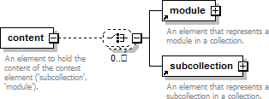
namespace | http://cnx.rice.edu/collxml
properties | content complex
children | module subcollection
used by | elements collection subcollection
annotation | documentation  An element to hold the content of the context element ('subcollection', 'module').
source | <xs:element name="content">  <xs:annotation>  <xs:documentation>An element to hold the content of the context element ('subcollection',

'module').</xs:documentation>
</xs:annotation>
<xs:complexType>
<xs:choice minOccurs="0" maxOccurs="unbounded">
<xs:element ref="module"/>
<xs:element ref="subcollection"/>
</xs:choice>
</xs:complexType>
</xs:element>

element metadata
diagram | 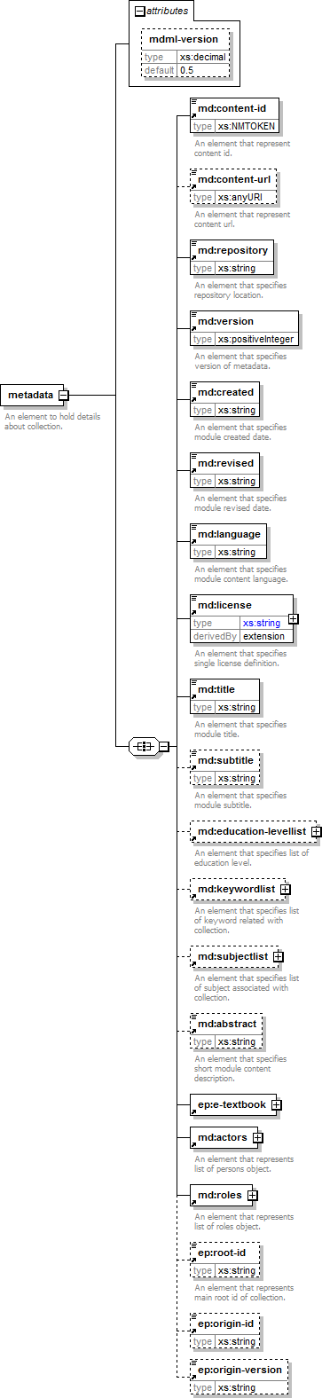
namespace | http://cnx.rice.edu/collxml
properties | content | complex
children | content-id content-url repository version created revised language license title subtitle education-levellist keywordlist subjectlist abstract e-textbook actors roles root-id origin-id origin-version
used by | element collection
attributes | Name Type Use Default Fixed Annotation mdml-version xs:decimal 0.5
annotation | documentation  An element to hold details about collection.
source | <xs:element name="metadata">  <xs:annotation>  <xs:documentation>An element to hold details about collection.</xs:documentation>  </xs:annotation>  <xs:complexType>  <xs:all>  <xs:element ref="md:content-id"/>  <xs:element ref="md:content-url" minOccurs="0"/>  <xs:element ref="md:repository"/>  <xs:element ref="md:version"/>  <xs:element ref="md:created"/>  <xs:element ref="md:revised"/>  <xs:element ref="md:language"/>  <xs:element ref="md:license"/>  <xs:element ref="md:title"/>  <xs:element ref="md:subtitle" minOccurs="0"/>  <xs:element ref="md:education-levellist" minOccurs="0"/>  <xs:element ref="md:keywordlist" minOccurs="0"/>  <xs:element ref="md:subjectlist" minOccurs="0"/>  <xs:element ref="md:abstract" minOccurs="0"/>  <xs:element ref="ep:e-textbook"/>  <xs:element ref="md:actors"/>  <xs:element ref="md:roles"/>  <xs:element ref="ep:root-id" minOccurs="0"/>  <xs:element ref="ep:origin-id" minOccurs="0"/>  <xs:element ref="ep:origin-version" minOccurs="0"/>  </xs:all>  <xs:attribute name="mdml-version" type="xs:decimal" default="0.5"/>  </xs:complexType>  </xs:element>

attribute metadata/@ mdml -version
type | xs:decimal
properties | default 0.5
source | <xs:attribute name="mdml-version" type="xs:decimal" default="0.5"/>

element module
diagram | 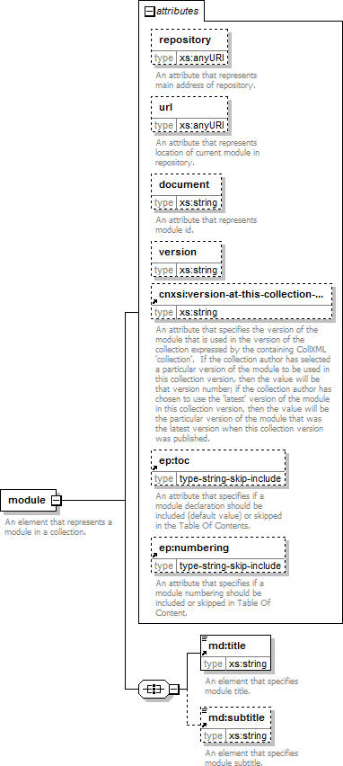
namespace | http://cnx.rice.edu/collxml
properties | content | complex
children | title subtitle
used by | element content
attributes | Name Type Use Default Fixed Annotation repository xs:anyURI documentation  An attribute that represents  main address
 |  |  |  | of repository.
 | url |  | xs:anyURI | documentation An attribute that represents location of current module in  repository.
 | document |  | xs:string | documentation An attribute that represents  module id.
 | version |  | xs:string
 | cnxsi:version-at- this-collection- version |  | xs:string | documentation An attribute that specifies the version of the module that is used in the version of the collection expressed by the containing CollXML 'collection'. If the collection author has selected a particular version of the module to be used in this collection version, then the value will be that version number; if the collection author has chosen to use the 'latest' version of the module in this collection version, then the value will be the particular version of the module that was the latest version when this collection version was  published.
 | ep:toc |  | type-string- skip-include | documentation An attribute that specifies if a module declaration should be included (default value) or skipped in the Table Of  Contents.
 | ep:numbering |  | type-string- | documentation

 | skip-include | An attribute that specifies if a module numbering should be included or skipped in Table Of  Content.
annotation | documentation
 | An element that represents a module in a collection.
source | <xs:element name="module">  <xs:annotation>  <xs:documentation>An element that represents a module in a collection.</xs:documentation>  </xs:annotation>  <xs:complexType>  <xs:all>  <xs:element ref="md:title"/>  <xs:element ref="md:subtitle" minOccurs="0"/>  </xs:all>  <xs:attribute name="repository" type="xs:anyURI">  <xs:annotation>  <xs:documentation>An attribute that represents main address of repository.</xs:documentation>  </xs:annotation>  </xs:attribute>  <xs:attribute name="url" type="xs:anyURI">  <xs:annotation>  <xs:documentation>An attribute that represents location of current module in repository.</xs:documentation>  </xs:annotation>  </xs:attribute>  <xs:attribute name="document" type="xs:string">  <xs:annotation>  <xs:documentation>An attribute that represents module id.</xs:documentation>  </xs:annotation>  </xs:attribute>  <xs:attribute name="version" type="xs:string"/>  <xs:attribute ref="cnxsi:version-at-this-collection-version"/>  <xs:attribute ref="ep:toc"/>  <xs:attribute ref="ep:numbering"/>  </xs:complexType>  </xs:element>

attribute module/@ repository
type | xs:anyURI
annotation | documentation  An attribute that represents main address of repository.
source | <xs:attribute name="repository" type="xs:anyURI">  <xs:annotation>  <xs:documentation>An attribute that represents main address of repository.</xs:documentation>  </xs:annotation>  </xs:attribute>

attribute module/@ url
type | xs:anyURI
annotation | documentation  An attribute that represents location of current module in repository.
source | <xs:attribute name="url" type="xs:anyURI">  <xs:annotation>  <xs:documentation>An attribute that represents location of current module in repository.</xs:documentation>  </xs:annotation>  </xs:attribute>

attribute module/@ document
type | xs:string
annotation | documentation  An attribute that represents module id.
source | <xs:attribute name="document" type="xs:string">  <xs:annotation>  <xs:documentation>An attribute that represents module id.</xs:documentation>  </xs:annotation>  </xs:attribute>

attribute module/@ version
type | xs:string
source | <xs:attribute name="version" type="xs:string"/>

element subcollection
diagram | 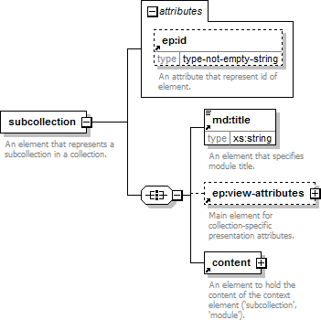
namespace | http://cnx.rice.edu/collxml
properties | content complex
children | title view-attributes content
used by | element | content
attributes | Name | Type | Use | Default | Fixed | Annotation
 | ep:id | type-not-empty- string |  |  |  | documentation An attribute  that represent id of element.
annotation | documentation
 | An element that represents a subcollection in a collection.
source | <xs:element name="subcollection">  <xs:annotation>  <xs:documentation>An element that represents a subcollection in a collection.</xs:documentation>  </xs:annotation>  <xs:complexType>  <xs:all>  <xs:element ref="md:title"/>  <xs:element ref="ep:view-attributes" minOccurs="0"/>  <xs:element ref="content"/>  </xs:all>  <xs:attribute ref="ep:id"/>  </xs:complexType>  </xs:element>

element abstract
diagram | 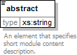
namespace | http://cnx.rice.edu/mdml
type | xs:string
properties | content simple
used by | element metadata
annotation | documentation  An element that specifies short module content description.
source | <xs:element name="abstract" type="xs:string">  <xs:annotation>  <xs:documentation>An element that specifies short module content description.</xs:documentation>  </xs:annotation>  </xs:element>

element actors
diagram | 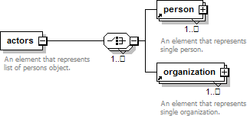
namespace | http://cnx.rice.edu/mdml
properties | content complex
children | person organization
used by | element metadata
annotation | documentation  An element that represents list of persons object.
source | <xs:element name="actors">  <xs:annotation>  <xs:documentation>An element that represents list of persons object.</xs:documentation>  </xs:annotation>  <xs:complexType>  <xs:choice minOccurs="1" maxOccurs="unbounded">  <xs:element ref="person" maxOccurs="unbounded"/>  <xs:element ref="organization" maxOccurs="unbounded"/>  </xs:choice>  </xs:complexType>  </xs:element>

element content-id
diagram | 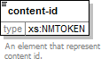
namespace | http://cnx.rice.edu/mdml
type | xs:NMTOKEN
properties | content simple
used by | element metadata
annotation | documentation  An element that represent content id.
source | <xs:element name="content-id" type="xs:NMTOKEN">  <xs:annotation>  <xs:documentation>An element that represent content id.</xs:documentation>  </xs:annotation>  </xs:element>

element content-url
diagram | 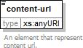
namespace | http://cnx.rice.edu/mdml
type | xs:anyURI
properties | content simple
used by | element metadata
annotation | documentation  An element that represent content url.
source | <xs:element name="content-url" type="xs:anyURI">  <xs:annotation>  <xs:documentation>An element that represent content url.</xs:documentation>  </xs:annotation>  </xs:element>

element created
diagram | 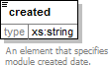
namespace | http://cnx.rice.edu/mdml
type | xs:string
properties | content simple
used by | element metadata
annotation | documentation  An element that specifies module created date.
source | <xs:element name="created" type="xs:string">  <xs:annotation>  <xs:documentation>An element that specifies module created date.</xs:documentation>  </xs:annotation>  </xs:element>

element education-levellist
diagram | 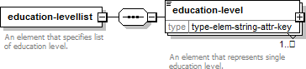
namespace | http://cnx.rice.edu/mdml
properties | content complex
children | education-level
used by | element metadata
annotation | documentation  An element that specifies list of education level.
source | <xs:element name="education-levellist">  <xs:annotation>  <xs:documentation>An element that specifies list of education level.</xs:documentation>  </xs:annotation>  <xs:complexType>  <xs:sequence>  <xs:element name="education-level" type="type-elem-string-attr-key" minOccurs="1" maxOccurs="unbounded">  <xs:annotation>  <xs:documentation>An element that represents single education level.</xs:documentation>  </xs:annotation>  </xs:element>  </xs:sequence>  </xs:complexType>  </xs:element>

element education-levellist/education-level
diagram | 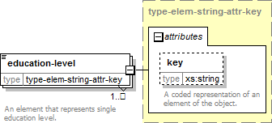
namespace | http://cnx.rice.edu/mdml
type | type-elem-string-attr-key
properties | minOcc | 1
 | maxOcc | unbounded
 | content | complex
attributes | Name | Type | Use | Default | Fixed | Annotation
 | key | xs:string |  |  |  | documentation A coded representation  of an element of the object.
annotation | documentation
 | An element that represents single education level.
source | <xs:element name="education-level" type="type-elem-string-attr-key" minOccurs="1" maxOccurs="unbounded">  <xs:annotation>  <xs:documentation>An element that represents single education level.</xs:documentation>  </xs:annotation>  </xs:element>

element keywordlist
diagram | 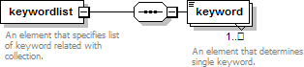
namespace | http://cnx.rice.edu/mdml
properties | content complex
children | keyword
used by | element metadata
annotation | documentation  An element that specifies list of keyword related with collection.
source | <xs:element name="keywordlist">  <xs:annotation>  <xs:documentation>An element that specifies list of keyword related with collection.</xs:documentation>  </xs:annotation>  <xs:complexType>  <xs:sequence>  <xs:element name="keyword" minOccurs="1" maxOccurs="unbounded">  <xs:annotation>  <xs:documentation>An element that determines single keyword.</xs:documentation>  </xs:annotation>  </xs:element>  </xs:sequence>  </xs:complexType>  </xs:element>

element keywordlist/keyword
diagram | 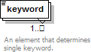
namespace | http://cnx.rice.edu/mdml
properties | minOcc 1  maxOcc unbounded
annotation | documentation  An element that determines single keyword.
source | <xs:element name="keyword" minOccurs="1" maxOccurs="unbounded">  <xs:annotation>  <xs:documentation>An element that determines single keyword.</xs:documentation>  </xs:annotation>  </xs:element>

element language
diagram | 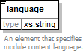
namespace | http://cnx.rice.edu/mdml
type | xs:string
properties | content simple
used by | element metadata
annotation | documentation  An element that specifies module content language.
source | <xs:element name="language" type="xs:string">  <xs:annotation>  <xs:documentation>An element that specifies module content language.</xs:documentation>  </xs:annotation>  </xs:element>

element license
diagram | 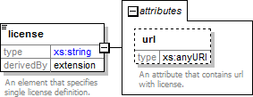
namespace | http://cnx.rice.edu/mdml
type | extension of xs:string
properties | content | complex
used by | element | metadata
attributes | Name | Type | Use | Default | Fixed | Annotation
 | url | xs:anyURI |  |  |  | documentation An attribute that contains url with license.
annotation | documentation
 | An element that specifies single license definition.
source | <xs:element name="license">  <xs:annotation>  <xs:documentation>An element that specifies single license definition.</xs:documentation>  </xs:annotation>  <xs:complexType>  <xs:simpleContent>  <xs:extension base="xs:string">  <xs:attribute name="url" type="xs:anyURI">  <xs:annotation>  <xs:documentation>An attribute that contains url with license.</xs:documentation>  </xs:annotation>  </xs:attribute>  </xs:extension>  </xs:simpleContent>  </xs:complexType>  </xs:element>

attribute license/@ url
type | xs:anyURI
annotation | documentation  An attribute that contains url with license.
source | <xs:attribute name="url" type="xs:anyURI">  <xs:annotation>  <xs:documentation>An attribute that contains url with license.</xs:documentation>  </xs:annotation>  </xs:attribute>

element organization
diagram | 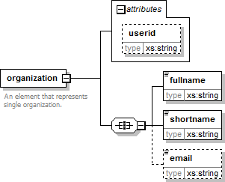
namespace | http://cnx.rice.edu/mdml
properties | content complex
children | fullname shortname email
used by | element actors
attributes | Name Type Use Default Fixed Annotation userid xs:string
annotation | documentation  An element that represents single organization.
source | <xs:element name="organization">  <xs:annotation>  <xs:documentation>An element that represents single organization.</xs:documentation>  </xs:annotation>  <xs:complexType>  <xs:all>  <xs:element name="fullname" type="xs:string"/>  <xs:element name="shortname" type="xs:string"/>  <xs:element name="email" type="xs:string" minOccurs="0"/>  </xs:all>  <xs:attribute name="userid" type="xs:string"/>  </xs:complexType>  </xs:element>

attribute organization/@ userid
type | xs:string
source | <xs:attribute name="userid" type="xs:string"/>

element organization/fullname
diagram | 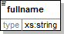
namespace | http://cnx.rice.edu/mdml
type | xs:string
properties | content simple
source | <xs:element name="fullname" type="xs:string"/>

element organization/shortname
diagram | 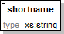
namespace | http://cnx.rice.edu/mdml
type | xs:string
properties | content simple
source | <xs:element name="shortname" type="xs:string"/>

element organization/email
diagram | 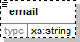
namespace | http://cnx.rice.edu/mdml
type | xs:string
properties | minOcc 0  maxOcc 1 content simple
source | <xs:element name="email" type="xs:string" minOccurs="0"/>

element person
diagram | 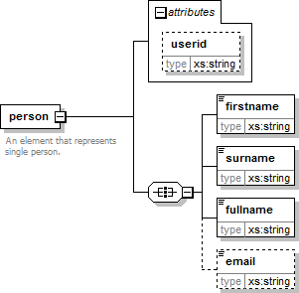
namespace | http://cnx.rice.edu/mdml
properties | content complex
children | firstname surname fullname email
used by | element actors
attributes | Name Type Use Default Fixed Annotation userid xs:string
annotation | documentation  An element that represents single person.
source | <xs:element name="person">  <xs:annotation>  <xs:documentation>An element that represents single person.</xs:documentation>  </xs:annotation>  <xs:complexType>  <xs:all>  <xs:element name="firstname" type="xs:string"/>  <xs:element name="surname" type="xs:string"/>  <xs:element name="fullname" type="xs:string"/>  <xs:element name="email" type="xs:string" minOccurs="0"/>  </xs:all>  <xs:attribute name="userid" type="xs:string"/>  </xs:complexType>  </xs:element>

attribute person/@ userid
type | xs:string
source | <xs:attribute name="userid" type="xs:string"/>

element person/firstname
diagram | 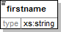
namespace | http://cnx.rice.edu/mdml
type | xs:string
properties | content simple
source | <xs:element name="firstname" type="xs:string"/>

element person/surname
diagram | 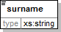
namespace | http://cnx.rice.edu/mdml
type | xs:string
properties | content simple
source | <xs:element name="surname" type="xs:string"/>

element person/fullname
diagram
namespace | http://cnx.rice.edu/mdml
type | xs:string
properties | content simple
source | <xs:element name="fullname" type="xs:string"/>

element person/email
diagram
namespace | http://cnx.rice.edu/mdml
type | xs:string
properties | minOcc 0  maxOcc 1 content simple
source | <xs:element name="email" type="xs:string" minOccurs="0"/>

element repository
diagram | 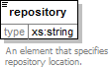
namespace | http://cnx.rice.edu/mdml

type | xs:string
properties | content simple
used by | element metadata
annotation | documentation  An element that specifies repository location.
source | <xs:element name="repository" type="xs:string">  <xs:annotation>  <xs:documentation>An element that specifies repository location.</xs:documentation>  </xs:annotation>  </xs:element>

element revised
diagram | 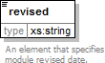
namespace | http://cnx.rice.edu/mdml
type | xs:string
properties | content simple
used by | element metadata
annotation | documentation  An element that specifies module revised date.
source | <xs:element name="revised" type="xs:string">  <xs:annotation>  <xs:documentation>An element that specifies module revised date.</xs:documentation>  </xs:annotation>  </xs:element>

element role
diagram | 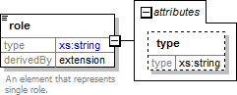
namespace | http://cnx.rice.edu/mdml
type | extension of xs:string
properties | content complex
used by | element roles
attributes | Name Type Use Default Fixed Annotation type xs:string
annotation | documentation  An element that represents single role.
source | <xs:element name="role">  <xs:annotation>  <xs:documentation>An element that represents single role.</xs:documentation>

</xs:annotation>
<xs:complexType>
<xs:simpleContent>
<xs:extension base="xs:string">
<xs:attribute name="type" type="xs:string"/>
</xs:extension>
</xs:simpleContent>
</xs:complexType>
</xs:element>

attribute role/@ type
type | xs:string
source | <xs:attribute name="type" type="xs:string"/>

element roles
diagram | 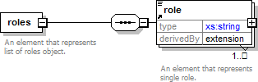
namespace | http://cnx.rice.edu/mdml
properties | content complex
children | role
used by | element metadata
annotation | documentation  An element that represents list of roles object.
source | <xs:element name="roles">  <xs:annotation>  <xs:documentation>An element that represents list of roles object.</xs:documentation>  </xs:annotation>  <xs:complexType>  <xs:sequence>  <xs:element ref="role" minOccurs="1" maxOccurs="unbounded"/>  </xs:sequence>  </xs:complexType>  </xs:element>

element subjectlist
diagram | 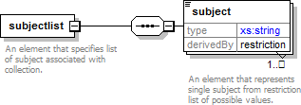
namespace | http://cnx.rice.edu/mdml

properties | content complex
children | subject
used by | element metadata
annotation | documentation  An element that specifies list of subject associated with collection.
source | <xs:element name="subjectlist">  <xs:annotation>  <xs:documentation>An element that specifies list of subject associated with collection.</xs:documentation>  </xs:annotation>  <xs:complexType>  <xs:sequence>  <xs:element name="subject" minOccurs="1" maxOccurs="unbounded">  <xs:annotation>  <xs:documentation>An element that represents single subject from restriction list of possible values.</xs:documentation>  </xs:annotation>  <xs:simpleType>  <xs:restriction base="xs:string">  <xs:enumeration value="matematyka"/>  <xs:enumeration value="język polski"/>  <xs:enumeration value="fizyka"/>  <xs:enumeration value="chemia"/>  <xs:enumeration value="biologia"/>  <xs:enumeration value="geografia"/>  <xs:enumeration value="przyroda"/>  <xs:enumeration value="edukacja wczesnoszkolna"/>  <xs:enumeration value="historia i społeczeństwo"/>  <xs:enumeration value="historia"/>  <xs:enumeration value="informatyka"/>  <xs:enumeration value="zajęcia komputerowe"/>  <xs:enumeration value="wiedza o społeczeństwie"/>  <xs:enumeration value="edukacja dla bezpieczeństwa"/>  </xs:restriction>  </xs:simpleType>  </xs:element>  </xs:sequence>  </xs:complexType>  </xs:element>

element subjectlist/subject
diagram | 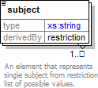
namespace | http://cnx.rice.edu/mdml
type | restriction of xs:string
properties | minOcc 1  maxOcc unbounded

 | content | simple
facets | Kind |  | Value | Annotation
 | enumeration |  | matematyka
 | enumeration |  | język polski
 | enumeration |  | fizyka
 | enumeration |  | chemia
 | enumeration |  | biologia
 | enumeration |  | geografia
 | enumeration |  | przyroda
 | enumeration |  | edukacja wczesnoszkolna
 | enumeration |  | historia i społeczeństwo
 | enumeration |  | historia
 | enumeration |  | informatyka
 | enumeration |  | zajęcia komputerowe
 | enumeration |  | wiedza o społeczeństwie
 | enumeration |  | edukacja dla bezpieczeństwa
annotation | documentation
 | An element that represents single subject from restriction list of possible values.
source | <xs:element name="subject" minOccurs="1" maxOccurs="unbounded">  <xs:annotation>  <xs:documentation>An element that represents single subject from restriction list of possible values.</xs:documentation>  </xs:annotation>  <xs:simpleType>  <xs:restriction base="xs:string">  <xs:enumeration value="matematyka"/>  <xs:enumeration value="język polski"/>  <xs:enumeration value="fizyka"/>  <xs:enumeration value="chemia"/>  <xs:enumeration value="biologia"/>  <xs:enumeration value="geografia"/>  <xs:enumeration value="przyroda"/>  <xs:enumeration value="edukacja wczesnoszkolna"/>  <xs:enumeration value="historia i społeczeństwo"/>  <xs:enumeration value="historia"/>  <xs:enumeration value="informatyka"/>  <xs:enumeration value="zajęcia komputerowe"/>  <xs:enumeration value="wiedza o społeczeństwie"/>  <xs:enumeration value="edukacja dla bezpieczeństwa"/>  </xs:restriction>  </xs:simpleType>  </xs:element>

element subtitle
diagram | 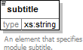
namespace | http://cnx.rice.edu/mdml
type | xs:string

properties | content simple
used by | elements metadata module
annotation | documentation  An element that specifies module subtitle.
source | <xs:element name="subtitle" type="xs:string">  <xs:annotation>  <xs:documentation>An element that specifies module subtitle.</xs:documentation>  </xs:annotation>  </xs:element>

element title
diagram | 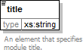
namespace | http://cnx.rice.edu/mdml
type | xs:string
properties | content simple
used by | elements metadata module subcollection
annotation | documentation  An element that specifies module title.
source | <xs:element name="title" type="xs:string">  <xs:annotation>  <xs:documentation>An element that specifies module title.</xs:documentation>  </xs:annotation>  </xs:element>

element version
diagram | 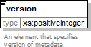
namespace | http://cnx.rice.edu/mdml
type | xs:positiveInteger
properties | content simple
used by | element metadata
annotation | documentation  An element that specifies version of metadata.
source | <xs:element name="version" type="xs:positiveInteger">  <xs:annotation>  <xs:documentation>An element that specifies version of metadata.</xs:documentation>  </xs:annotation>  </xs:element>

element collection-header
diagram | 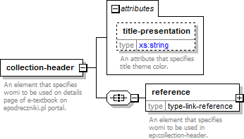
namespace | http://epodreczniki.pl/
properties | content | complex
children | reference
used by | element references
attributes | Name Type Use Default Fixed Annotation  title-presentation derived by: documentation  xs:string An attribute  that specifies title theme color.
annotation | documentation  An element that specifies womi to be used on details page of e-textbook on epodreczniki.pl portal.
source | <xs:element name="collection-header">  <xs:annotation>  <xs:documentation>An element that specifies womi to be used on details page of e-textbook on epodreczniki.pl portal.</xs:documentation>  </xs:annotation>  <xs:complexType>  <xs:all>  <xs:element name="reference" type="type-link-reference">  <xs:annotation>  <xs:documentation>An element that specifies womi to be used in ep:collection- header.</xs:documentation>  </xs:annotation>  </xs:element>  </xs:all>  <xs:attribute name="title-presentation">  <xs:annotation>  <xs:documentation>An attribute that specifies title theme color.</xs:documentation>  </xs:annotation>  <xs:simpleType>  <xs:restriction base="xs:string">  <xs:enumeration value="dark"/>  <xs:enumeration value="light"/>  </xs:restriction>  </xs:simpleType>  </xs:attribute>  </xs:complexType>  </xs:element>

attribute collection-header/@ title -presentation
type | restriction of xs:string
facets | Kind | Value | Annotation
 | enumeration | dark
 | enumeration | light
annotation | documentation
 | An attribute that specifies title theme color.
source | <xs:attribute name="title-presentation">  <xs:annotation>  <xs:documentation>An attribute that specifies title theme color.</xs:documentation>  </xs:annotation>  <xs:simpleType>  <xs:restriction base="xs:string">  <xs:enumeration value="dark"/>  <xs:enumeration value="light"/>  </xs:restriction>  </xs:simpleType>  </xs:attribute>

element collection-header/reference
diagram | 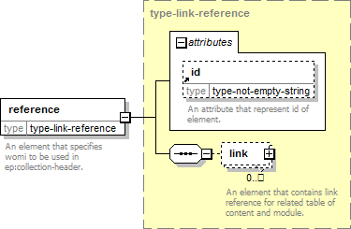
namespace | http://epodreczniki.pl/
type | type-link-reference
properties | content complex
children | link
attributes | Name Type Use Default Fixed Annotation  id type-not-empty- documentation  string An attribute  that represent id of element.
annotation | documentation  An element that specifies womi to be used in ep:collection-header.
source | <xs:element name="reference" type="type-link-reference">  <xs:annotation>  <xs:documentation>An element that specifies womi to be used in ep:collection- header.</xs:documentation>  </xs:annotation>  </xs:element>

element cover
diagram | 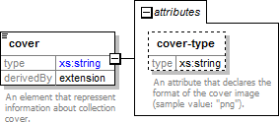
namespace | http://epodreczniki.pl/
type | extension of xs:string
properties | content | complex
used by | element | e-textbook
attributes | Name | Type | Use | Default | Fixed | Annotation
 | cover-type | xs:string |  |  |  | documentation An attribute that declares the format of the cover image (sample  value: "png").
annotation | documentation
 | An element that repressent information about collection cover.
source | <xs:element name="cover">  <xs:annotation>  <xs:documentation>An element that repressent information about collection cover.</xs:documentation>  </xs:annotation>  <xs:complexType>  <xs:simpleContent>  <xs:extension base="xs:string">  <xs:attribute name="cover-type" type="xs:string" form="qualified">  <xs:annotation>  <xs:documentation>An attribute that declares the format of the cover image (sample value: "png").</xs:documentation>  </xs:annotation>  </xs:attribute>  </xs:extension>  </xs:simpleContent>  </xs:complexType>  </xs:element>

attribute cover/@ cover -type
namespace | http://epodreczniki.pl/
type | xs:string
properties | form qualified
annotation | documentation  An attribute that declares the format of the cover image (sample value: "png").
source | <xs:attribute name="cover-type" type="xs:string" form="qualified">  <xs:annotation>  <xs:documentation>An attribute that declares the format of the cover image (sample value:
"png").</xs:documentation>
</xs:annotation>
</xs:attribute>

element e-textbook
diagram | 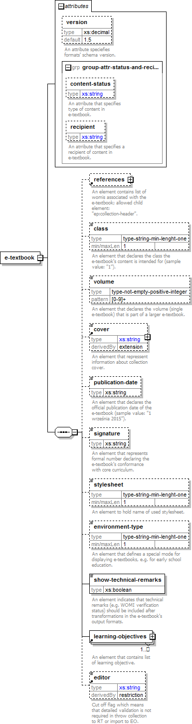
namespace | http://epodreczniki.pl/
properties | content complex
children | references class volume cover publication-date signature stylesheet environment-type show-technical-remarks learning-objectives editor

used by | element | metadata
attributes | Name |  | Type | Use | Default | Fixed | Annotation
 | version |  | xs:decimal |  | 1.5 |  | documentation An attribute speciefies formats' schema  version.
 | content-status |  | derived by: xs:string |  |  |  | documentation An atrribute that specifies type of content  in e-textbook.
 | recipient |  | derived by: xs:string |  |  |  | documentation An atrribute that specifies a recipient of content in e-  textbook.
source | <xs:element name="e-textbook">  <xs:complexType>  <xs:sequence>  <xs:element ref="references" minOccurs="0"/>  <xs:element name="class" type="type-string-min-lenght-one" minOccurs="0">  <xs:annotation>  <xs:documentation>An element that declares the class the e-textbook's content is intended for (sample value: "1").</xs:documentation>  </xs:annotation>  </xs:element>  <xs:element name="volume" type="type-not-empty-positive-integer" minOccurs="0">  <xs:annotation>  <xs:documentation>An element that declares the volume (single e-textbook) that is part of a larger e-textbook.</xs:documentation>  </xs:annotation>  </xs:element>  <xs:element ref="cover" minOccurs="0"/>  <xs:element name="publication-date" type="xs:string" minOccurs="0">  <xs:annotation>  <xs:documentation>An element that declares the official publication date of the e-textbook (sample value: "1 września 2015").</xs:documentation>  </xs:annotation>  </xs:element>  <xs:element name="signature" type="xs:string" minOccurs="0">  <xs:annotation>  <xs:documentation>An element that represents formal number declaring the e-textbook's conformance with core curriculum.</xs:documentation>  </xs:annotation>  </xs:element>  <xs:element name="stylesheet" type="type-string-min-lenght-one" minOccurs="0">  <xs:annotation>  <xs:documentation>An element to hold name of used stylesheet.</xs:documentation>  </xs:annotation>  </xs:element>  <xs:element name="environment-type" type="type-string-min-lenght-one" minOccurs="0">  <xs:annotation>  <xs:documentation>An element that defines a special mode for displaying e-textbooks, e.g. for early school education.</xs:documentation>  </xs:annotation>

</xs:element>
<xs:element name="show-technical-remarks" type="xs:boolean">
<xs:annotation>
<xs:documentation>An element indicates that technical remarks (e.g. WOMI verification status) should be included after transformations in the e-textbook's output formats.</xs:documentation>
</xs:annotation>
</xs:element>
<xs:element ref="learning-objectives" maxOccurs="unbounded"/>
<xs:element ref="editor" minOccurs="0"/>
</xs:sequence>
<xs:attribute name="version" type="xs:decimal" default="1.5" form="qualified">
<xs:annotation>
<xs:documentation>An attribute speciefies formats' schema version.</xs:documentation>
</xs:annotation>
</xs:attribute>
<xs:attributeGroup ref="group-attr-status-and-recipient"/>
</xs:complexType>
</xs:element>

attribute e-textbook/@ version
namespace | http://epodreczniki.pl/
type | xs:decimal
properties | default 1.5  form qualified
annotation | documentation  An attribute speciefies formats' schema version.
source | <xs:attribute name="version" type="xs:decimal" default="1.5" form="qualified">  <xs:annotation>  <xs:documentation>An attribute speciefies formats' schema version.</xs:documentation>  </xs:annotation>  </xs:attribute>

element e-textbook/class
diagram | 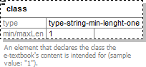
namespace | http://epodreczniki.pl/
type | type-string-min-lenght-one
properties | minOcc 0  maxOcc 1 content simple
facets | Kind Value Annotation  minLength 1
annotation | documentation  An element that declares the class the e-textbook's content is intended for (sample value: "1").
source | <xs:element name="class" type="type-string-min-lenght-one" minOccurs="0">  <xs:annotation>

<xs:documentation>An element that declares the class the e-textbook's content is intended for (sample value: "1").</xs:documentation>
</xs:annotation>
</xs:element>

element e-textbook/volume
diagram | 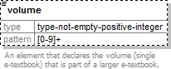
namespace | http://epodreczniki.pl/
type | type-not-empty-positive-integer
properties | minOcc 0  maxOcc 1 content simple
facets | Kind Value Annotation  pattern [0-9]+
annotation | documentation  An element that declares the volume (single e-textbook) that is part of a larger e-textbook.
source | <xs:element name="volume" type="type-not-empty-positive-integer" minOccurs="0">  <xs:annotation>  <xs:documentation>An element that declares the volume (single e-textbook) that is part of a larger e-textbook.</xs:documentation>  </xs:annotation>  </xs:element>

element e-textbook/publication-date
diagram | 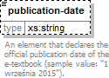
namespace | http://epodreczniki.pl/
type | xs:string
properties | minOcc 0  maxOcc 1 content simple
annotation | documentation  An element that declares the official publication date of the e-textbook (sample value: "1 września 2015").
source | <xs:element name="publication-date" type="xs:string" minOccurs="0">  <xs:annotation>  <xs:documentation>An element that declares the official publication date of the e-textbook (sample value: "1 września 2015").</xs:documentation>  </xs:annotation>  </xs:element>

element e-textbook/signature
diagram | 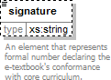
namespace | http://epodreczniki.pl/
type | xs:string
properties | minOcc 0  maxOcc 1 content simple
annotation | documentation  An element that represents formal number declaring the e-textbook's conformance with core curriculum.
source | <xs:element name="signature" type="xs:string" minOccurs="0">  <xs:annotation>  <xs:documentation>An element that represents formal number declaring the e-textbook's conformance with core curriculum.</xs:documentation>  </xs:annotation>  </xs:element>

element e-textbook/stylesheet
diagram | 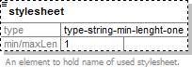
namespace | http://epodreczniki.pl/
type | type-string-min-lenght-one
properties | minOcc 0  maxOcc 1 content simple
facets | Kind Value Annotation  minLength 1
annotation | documentation  An element to hold name of used stylesheet.
source | <xs:element name="stylesheet" type="type-string-min-lenght-one" minOccurs="0">  <xs:annotation>  <xs:documentation>An element to hold name of used stylesheet.</xs:documentation>  </xs:annotation>  </xs:element>

element e-textbook/environment-type
diagram | 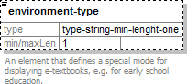
namespace | http://epodreczniki.pl/
type | type-string-min-lenght-one
properties | minOcc | 0
 | maxOcc | 1
 | content | simple
facets | Kind | Value | Annotation
 | minLength | 1
annotation | documentation
 | An element that defines a special mode for displaying e-textbooks, e.g. for early school education.
source | <xs:element name="environment-type" type="type-string-min-lenght-one" minOccurs="0">  <xs:annotation>  <xs:documentation>An element that defines a special mode for displaying e-textbooks, e.g. for early school education.</xs:documentation>  </xs:annotation>  </xs:element>

element e-textbook/show-technical-remarks
diagram | 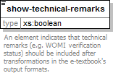
namespace | http://epodreczniki.pl/
type | xs:boolean
properties | content simple
annotation | documentation  An element indicates that technical remarks (e.g. WOMI verification status) should be included after transformations in the e-textbook's output formats.
source | <xs:element name="show-technical-remarks" type="xs:boolean">  <xs:annotation>  <xs:documentation>An element indicates that technical remarks (e.g. WOMI verification status) should be included after transformations in the e-textbook's output formats.</xs:documentation>  </xs:annotation>  </xs:element>

element editor
diagram | 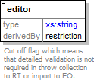
namespace | http://epodreczniki.pl/
type | restriction of xs:string
properties | content simple
used by | element e-textbook
facets | Kind Value Annotation  enumeration external-in- documentation

 |  | progress | Version was thrown from outer editor. The next versions will be throw from outer  editor also.
 | enumeration | external-final | documentation  Last version was thrown from outer editor. There will not be next versions.
 | enumeration | edition-online | documentation  Version was thrown (sealed) from EO.
annotation | documentation
 | Cut off flag which means that detailed validation is not required in throw collection to RT or import to EO.
source | <xs:element name="editor">  <xs:annotation>  <xs:documentation>Cut off flag which means that detailed validation is not required in throw collection to RT or import to EO.</xs:documentation>  </xs:annotation>  <xs:simpleType>  <xs:restriction base="xs:string">  <xs:enumeration value="external-in-progress">  <xs:annotation>  <xs:documentation>Version was thrown from outer editor. The next versions will be throw from outer editor also.</xs:documentation>  </xs:annotation>  </xs:enumeration>  <xs:enumeration value="external-final">  <xs:annotation>  <xs:documentation>Last version was thrown from outer editor. There will not be next versions.</xs:documentation>  </xs:annotation>  </xs:enumeration>  <xs:enumeration value="edition-online">  <xs:annotation>  <xs:documentation>Version was thrown (sealed) from EO.</xs:documentation>  </xs:annotation>  </xs:enumeration>  </xs:restriction>  </xs:simpleType>  </xs:element>

element learning-objectives
diagram | 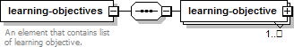
namespace | http://epodreczniki.pl/
properties | content complex
children | learning-objective
used by | element e-textbook
annotation | documentation  An element that contains list of learning objective.
source | <xs:element name="learning-objectives">  <xs:annotation>  <xs:documentation>An element that contains list of learning objective.</xs:documentation>  </xs:annotation>  <xs:complexType>  <xs:sequence>

<xs:element name="learning-objective" maxOccurs="unbounded">
<xs:complexType>
<xs:all>
<xs:element name="learning-objective-stage" type="type-elem-string-attr-key-qualified">
<xs:annotation>
<xs:documentation>An element that declares the education level of the learning objective.</xs:documentation>
</xs:annotation>
</xs:element>
<xs:element name="learning-objective-school" type="type-elem-string-attr-key-qualified">
<xs:annotation>
<xs:documentation>An element that declares the school type of the learning objective.</xs:documentation>
</xs:annotation>
</xs:element>
<xs:element name="learning-objective-version" type="type-elem-string-attr-key-qualified">
<xs:annotation>
<xs:documentation>An element that declares the version of the learning objective.</xs:documentation>
</xs:annotation>
</xs:element>
<xs:element name="learning-objective-subject" type="type-elem-string-attr-key-qualified" minOccurs="0">
<xs:annotation>
<xs:documentation>An element that declares the subject of the learning objective.</xs:documentation>
</xs:annotation>
</xs:element>
<xs:element name="learning-objective-scope" type="type-elem-string-attr-key-qualified" minOccurs="0">
<xs:annotation>
<xs:documentation>An element that declares the scope of the learning objective (e.g. elementary, expanding).</xs:documentation>
</xs:annotation>
</xs:element>
<xs:element name="learning-objective-text" type="xs:string" minOccurs="0">
<xs:annotation>
<xs:documentation>An element that contains detailed text description of the learning objective (sample value: "A student interprets mathematical text. After solving an exercise, he interprets the result").</xs:documentation>
</xs:annotation>
</xs:element>
<xs:element name="learning-objective-name" type="type-elem-string-attr-key-qualified">
<xs:annotation>
<xs:documentation>An element that represents general text description of the learning objective (sample value: "Creating and using information").</xs:documentation>
</xs:annotation>
</xs:element>
</xs:all>
</xs:complexType>
</xs:element>
</xs:sequence>
</xs:complexType>
</xs:element>

element learning-objectives/learning-objective
diagram | 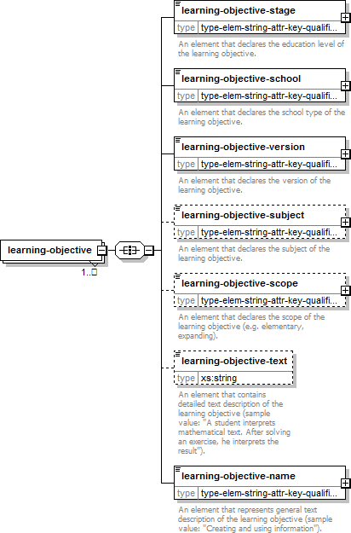
namespace | http://epodreczniki.pl/
properties | minOcc 1  maxOcc unbounded content complex
children | learning-objective-stage learning-objective-school learning-objective-version learning-objective-subject learning- objective-scope learning-objective-text learning-objective-name
source | <xs:element name="learning-objective" maxOccurs="unbounded">  <xs:complexType>  <xs:all>  <xs:element name="learning-objective-stage" type="type-elem-string-attr-key-qualified">  <xs:annotation>  <xs:documentation>An element that declares the education level of the learning objective.</xs:documentation>  </xs:annotation>  </xs:element>  <xs:element name="learning-objective-school" type="type-elem-string-attr-key-qualified">  <xs:annotation>  <xs:documentation>An element that declares the school type of the learning objective.</xs:documentation>
</xs:annotation>
</xs:element>
<xs:element name="learning-objective-version" type="type-elem-string-attr-key-qualified">
<xs:annotation>
<xs:documentation>An element that declares the version of the learning objective.</xs:documentation>
</xs:annotation>
</xs:element>
<xs:element name="learning-objective-subject" type="type-elem-string-attr-key-qualified" minOccurs="0">
<xs:annotation>
<xs:documentation>An element that declares the subject of the learning objective.</xs:documentation>
</xs:annotation>
</xs:element>
<xs:element name="learning-objective-scope" type="type-elem-string-attr-key-qualified" minOccurs="0">
<xs:annotation>
<xs:documentation>An element that declares the scope of the learning objective (e.g. elementary, expanding).</xs:documentation>
</xs:annotation>
</xs:element>
<xs:element name="learning-objective-text" type="xs:string" minOccurs="0">
<xs:annotation>
<xs:documentation>An element that contains detailed text description of the learning objective (sample value: "A student interprets mathematical text. After solving an exercise, he interprets the result").</xs:documentation>
</xs:annotation>
</xs:element>
<xs:element name="learning-objective-name" type="type-elem-string-attr-key-qualified">
<xs:annotation>
<xs:documentation>An element that represents general text description of the learning objective (sample value: "Creating and using information").</xs:documentation>
</xs:annotation>
</xs:element>
</xs:all>
</xs:complexType>
</xs:element>

element learning-objectives/learning-objective/learning-objective-stage
diagram | 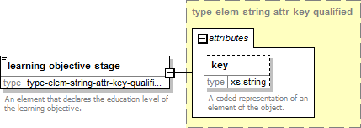
namespace | http://epodreczniki.pl/
type | type-elem-string-attr-key-qualified
properties | content complex

attributes | Name | Type | Use | Default | Fixed | Annotation
 | key | xs:string |  |  |  | documentation A coded representation of an element  of the object.
annotation | documentation
 | An element that declares the education level of the learning objective.
source | <xs:element name="learning-objective-stage" type="type-elem-string-attr-key-qualified">  <xs:annotation>  <xs:documentation>An element that declares the education level of the learning objective.</xs:documentation>  </xs:annotation>  </xs:element>

element learning-objectives/learning-objective/learning-objective-school
diagram | 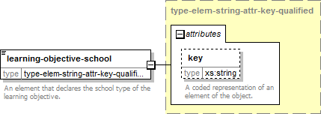
namespace | http://epodreczniki.pl/
type | type-elem-string-attr-key-qualified
properties | content | complex
attributes | Name Type Use Default Fixed Annotation  key xs:string documentation  A coded representation of an element of the object.
annotation | documentation  An element that declares the school type of the learning objective.
source | <xs:element name="learning-objective-school" type="type-elem-string-attr-key-qualified">  <xs:annotation>  <xs:documentation>An element that declares the school type of the learning objective.</xs:documentation>  </xs:annotation>  </xs:element>

element learning-objectives/learning-objective/learning-objective-version
diagram | 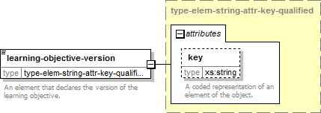
namespace | http://epodreczniki.pl/
type | type-elem-string-attr-key-qualified
properties | content | complex
attributes | Name Type Use Default Fixed Annotation  key xs:string documentation  A coded representation of an element  of the object.
annotation | documentation  An element that declares the version of the learning objective.
source | <xs:element name="learning-objective-version" type="type-elem-string-attr-key-qualified">  <xs:annotation>  <xs:documentation>An element that declares the version of the learning objective.</xs:documentation>  </xs:annotation>  </xs:element>

element learning-objectives/learning-objective/learning-objective-subject
diagram | 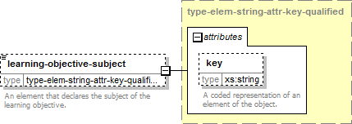
namespace | http://epodreczniki.pl/
type | type-elem-string-attr-key-qualified
properties | minOcc | 0
 | maxOcc | 1
 | content | complex
attributes | Name | Type | Use | Default | Fixed | Annotation
 | key | xs:string |  |  |  | documentation A coded representation  of an element of the object.
annotation | documentation
 | An element that declares the subject of the learning objective.
source | <xs:element name="learning-objective-subject" type="type-elem-string-attr-key-qualified" minOccurs="0">
<xs:annotation>
<xs:documentation>An element that declares the subject of the learning objective.</xs:documentation>
</xs:annotation>
</xs:element>

element learning-objectives/learning-objective/learning-objective-scope
diagram | 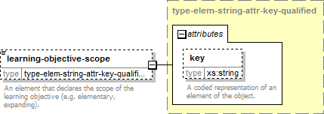
namespace | http://epodreczniki.pl/
type | type-elem-string-attr-key-qualified
properties | minOcc | 0
 | maxOcc | 1
 | content | complex
attributes | Name | Type | Use | Default | Fixed | Annotation
 | key | xs:string |  |  |  | documentation A coded representation  of an element of the object.
annotation | documentation
 | An element that declares the scope of the learning objective (e.g. elementary, expanding).
source | <xs:element name="learning-objective-scope" type="type-elem-string-attr-key-qualified" minOccurs="0">  <xs:annotation>  <xs:documentation>An element that declares the scope of the learning objective (e.g. elementary, expanding).</xs:documentation>  </xs:annotation>  </xs:element>

element learning-objectives/learning-objective/learning-objective-text
diagram | 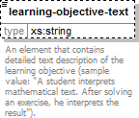
namespace | http://epodreczniki.pl/
type | xs:string
properties | minOcc 0  maxOcc 1 content simple
annotation | documentation

An element that contains detailed text description of the learning objective (sample value: "A student interprets
mathematical text. After solving an exercise, he interprets the result").
source | <xs:element name="learning-objective-text" type="xs:string" minOccurs="0">  <xs:annotation>  <xs:documentation>An element that contains detailed text description of the learning objective (sample value: "A student interprets mathematical text. After solving an exercise, he interprets the result").</xs:documentation>  </xs:annotation>  </xs:element>

element learning-objectives/learning-objective/learning-objective-name
diagram | 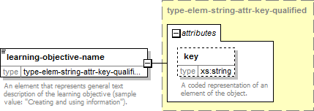
namespace | http://epodreczniki.pl/
type | type-elem-string-attr-key-qualified
properties | content | complex
attributes | Name Type Use Default Fixed Annotation  key xs:string documentation  A coded representation of an element of the object.
annotation | documentation  An element that represents general text description of the learning objective (sample value: "Creating and using information").
source | <xs:element name="learning-objective-name" type="type-elem-string-attr-key-qualified">  <xs:annotation>  <xs:documentation>An element that represents general text description of the learning objective (sample value: "Creating and using information").</xs:documentation>  </xs:annotation>  </xs:element>

element origin-id
diagram | 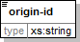
namespace | http://epodreczniki.pl/
type | xs:string
properties | content simple
used by | element metadata
source | <xs:element name="origin-id" type="xs:string"/>

element origin-version
diagram | 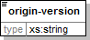
namespace | http://epodreczniki.pl/
type | xs:string
properties | content simple
used by | element metadata
source | <xs:element name="origin-version" type="xs:string"/>

element references
diagram | 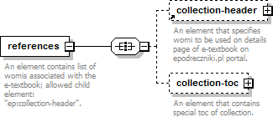
namespace | http://epodreczniki.pl/
properties | content complex
children | collection-header collection-toc
used by | element e-textbook
annotation | documentation  An element contains list of womis associated with the e-textbook; allowed child element: "ep:collection-header".
source | <xs:element name="references">  <xs:annotation>  <xs:documentation>An element contains list of womis associated with the e-textbook; allowed child element: "ep:collection-header".</xs:documentation>  </xs:annotation>  <xs:complexType>  <xs:all>  <xs:element ref="collection-header" minOccurs="0"/>  <xs:element name="collection-toc" minOccurs="0">  <xs:annotation>  <xs:documentation>An element that contains special toc of collection.</xs:documentation>  </xs:annotation>  <xs:complexType>  <xs:all>  <xs:element name="reference" type="type-link-reference">  <xs:annotation>  <xs:documentation>An element specifies womi to be used in ep:collection- toc.</xs:documentation>  </xs:annotation>  </xs:element>  </xs:all>
</xs:complexType>
</xs:element>
</xs:all>
</xs:complexType>
</xs:element>

element references/collection-toc
diagram | 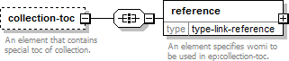
namespace | http://epodreczniki.pl/
properties | minOcc 0  maxOcc 1 content complex
children | reference
annotation | documentation  An element that contains special toc of collection.
source | <xs:element name="collection-toc" minOccurs="0">  <xs:annotation>  <xs:documentation>An element that contains special toc of collection.</xs:documentation>  </xs:annotation>  <xs:complexType>  <xs:all>  <xs:element name="reference" type="type-link-reference">  <xs:annotation>  <xs:documentation>An element specifies womi to be used in ep:collection- toc.</xs:documentation>  </xs:annotation>  </xs:element>  </xs:all>  </xs:complexType>  </xs:element>

element references/collection-toc/reference
diagram | 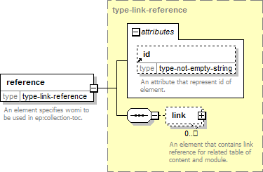
namespace | http://epodreczniki.pl/

type | type-link-reference
properties | content | complex
children | link
attributes | Name Type Use Default Fixed Annotation  id type-not-empty- documentation  string An attribute  that represent  id of element.
annotation | documentation  An element specifies womi to be used in ep:collection-toc.
source | <xs:element name="reference" type="type-link-reference">  <xs:annotation>  <xs:documentation>An element specifies womi to be used in ep:collection- toc.</xs:documentation>  </xs:annotation>  </xs:element>

element root-id
diagram | 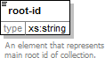
namespace | http://epodreczniki.pl/
type | xs:string
properties | content simple
used by | element metadata
annotation | documentation  An element that represents main root id of collection.
source | <xs:element name="root-id" type="xs:string">  <xs:annotation>  <xs:documentation>An element that represents main root id of collection.</xs:documentation>  </xs:annotation>  </xs:element>

element view-attributes
diagram | 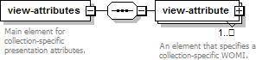
namespace | http://epodreczniki.pl/
properties | content complex
children | view-attribute
used by | element subcollection
annotation | documentation  Main element for collection-specific presentation attributes.
source | <xs:element name="view-attributes">

<xs:annotation>
<xs:documentation>Main element for collection-specific presentation attributes.</xs:documentation>
</xs:annotation>
<xs:complexType>
<xs:sequence>
<xs:element name="view-attribute" minOccurs="1" maxOccurs="unbounded">
<xs:annotation>
<xs:documentation>An element that specifies a collection-specific WOMI.</xs:documentation>
</xs:annotation>
<xs:complexType>
<xs:attribute ref="id">
<xs:annotation>
<xs:documentation>An identifier for a WOMI used in collection's presentation attribute.</xs:documentation>
</xs:annotation>
</xs:attribute>
<xs:attribute name="type" type="xs:string" form="qualified">
<xs:annotation>
<xs:documentation>An attribute that represents type of the collection's presentation attribute (sample value: "panorama").</xs:documentation>
</xs:annotation>
</xs:attribute>
<xs:attribute name="value" type="xs:string" form="qualified">
<xs:annotation>
<xs:documentation>An attribute that represents value of the collection's presentation attribute (sample value: "#ABCDEF").</xs:documentation>
</xs:annotation>
</xs:attribute>
<!--<xs:assert test="@ep:type and (@ep:id or @ep:value)"/>-->
</xs:complexType>
</xs:element>
</xs:sequence>
</xs:complexType>
</xs:element>

element view-attributes/view-attribute
diagram | 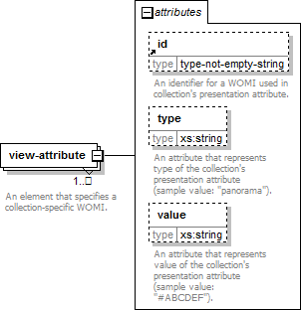
namespace | http://epodreczniki.pl/
properties | minOcc | 1
 | maxOcc | unbounded
 | content | complex
attributes | Name | Type | Use | Default | Fixed | Annotation
 | id | type-not-empty- string |  |  |  | documentation An identifier for a WOMI used in collection's presentation  attribute.
 | type | xs:string |  |  |  | documentation An attribute that represents type of the collection's presentation attribute (sample value:  "panorama").
 | value | xs:string |  |  |  | documentation An attribute that represents value of the collection's presentation attribute (sample value:  "#ABCDEF").
annotation | documentation
 | An element that specifies a collection-specific WOMI.
source | <xs:element name="view-attribute" minOccurs="1" maxOccurs="unbounded">  <xs:annotation>  <xs:documentation>An element that specifies a collection-specific WOMI.</xs:documentation>  </xs:annotation>  <xs:complexType>  <xs:attribute ref="id">  <xs:annotation>  <xs:documentation>An identifier for a WOMI used in collection's presentation attribute.</xs:documentation>
</xs:annotation>
</xs:attribute>
<xs:attribute name="type" type="xs:string" form="qualified">
<xs:annotation>
<xs:documentation>An attribute that represents type of the collection's presentation attribute (sample value: "panorama").</xs:documentation>
</xs:annotation>
</xs:attribute>
<xs:attribute name="value" type="xs:string" form="qualified">
<xs:annotation>
<xs:documentation>An attribute that represents value of the collection's presentation attribute (sample value: "#ABCDEF").</xs:documentation>
</xs:annotation>
</xs:attribute>
<!--<xs:assert test="@ep:type and (@ep:id or @ep:value)"/>-->
</xs:complexType>
</xs:element>

attribute view-attributes/view-attribute/@ type
namespace | http://epodreczniki.pl/
type | xs:string
properties | form qualified
annotation | documentation  An attribute that represents type of the collection's presentation attribute (sample value: "panorama").
source | <xs:attribute name="type" type="xs:string" form="qualified">  <xs:annotation>  <xs:documentation>An attribute that represents type of the collection's presentation attribute (sample value: "panorama").</xs:documentation>  </xs:annotation>  </xs:attribute>

attribute view-attributes/view-attribute/@ value
namespace | http://epodreczniki.pl/
type | xs:string
properties | form qualified
annotation | documentation  An attribute that represents value of the collection's presentation attribute (sample value: "#ABCDEF").
source | <xs:attribute name="value" type="xs:string" form="qualified">  <xs:annotation>  <xs:documentation>An attribute that represents value of the collection's presentation attribute (sample value: "#ABCDEF").</xs:documentation>  </xs:annotation>  </xs:attribute>

complexType type-link-reference
diagram | 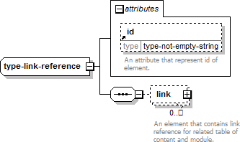
namespace | http://epodreczniki.pl/
children | link
used by | elements | collection-header/reference references/collection-toc/reference
attributes | Name | Type | Use | Default | Fixed | Annotation
 | id | type-not-empty- string |  |  |  | documentation An attribute  that represent id of element.
source | <xs:complexType name="type-link-reference">  <xs:sequence>  <xs:element name="link" minOccurs="0" maxOccurs="unbounded">  <xs:annotation>  <xs:documentation>An element that contains link reference for related table of content and module.</xs:documentation>  </xs:annotation>  <xs:complexType>  <xs:attribute name="toc-id" type="type-not-empty-string" form="qualified">  <xs:annotation>  <xs:documentation>An attribute specifies id of related table of content.</xs:documentation>  </xs:annotation>  </xs:attribute>  <xs:attribute name="module-id" type="type-not-empty-string" form="qualified">  <xs:annotation>  <xs:documentation>An attribute specifies id of related module.</xs:documentation>  </xs:annotation>  </xs:attribute>  </xs:complexType>  </xs:element>  </xs:sequence>  <xs:attribute ref="id"/>  </xs:complexType>

element type-link-reference/link
diagram | 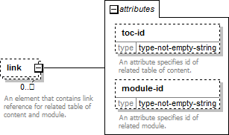
namespace | http://epodreczniki.pl/
properties | minOcc | 0
 | maxOcc | unbounded
 | content | complex
attributes | Name | Type | Use | Default | Fixed | Annotation
 | toc-id | type-not-empty- string |  |  |  | documentation An attribute specifies id of related table  of content.
 | module-id | type-not-empty- string |  |  |  | documentation An attribute specifies id of related  module.
annotation | documentation
 | An element that contains link reference for related table of content and module.
source | <xs:element name="link" minOccurs="0" maxOccurs="unbounded">  <xs:annotation>  <xs:documentation>An element that contains link reference for related table of content and module.</xs:documentation>  </xs:annotation>  <xs:complexType>  <xs:attribute name="toc-id" type="type-not-empty-string" form="qualified">  <xs:annotation>  <xs:documentation>An attribute specifies id of related table of content.</xs:documentation>  </xs:annotation>  </xs:attribute>  <xs:attribute name="module-id" type="type-not-empty-string" form="qualified">  <xs:annotation>  <xs:documentation>An attribute specifies id of related module.</xs:documentation>  </xs:annotation>  </xs:attribute>  </xs:complexType>  </xs:element>

attribute type-link-reference/link/@ toc -id
namespace | http://epodreczniki.pl/
type | type-not-empty-string
properties | form qualified
facets | Kind Value Annotation  pattern .+
annotation | documentation
 | An attribute specifies id of related table of content.
source | <xs:attribute name="toc-id" type="type-not-empty-string" form="qualified">  <xs:annotation>  <xs:documentation>An attribute specifies id of related table of content.</xs:documentation>  </xs:annotation>  </xs:attribute>

attribute type-link-reference/link/@ module -id
namespace | http://epodreczniki.pl/
type | type-not-empty-string
properties | form qualified
facets | Kind Value Annotation  pattern .+
annotation | documentation  An attribute specifies id of related module.
source | <xs:attribute name="module-id" type="type-not-empty-string" form="qualified">  <xs:annotation>  <xs:documentation>An attribute specifies id of related module.</xs:documentation>  </xs:annotation>  </xs:attribute>

attribute id
namespace | http://epodreczniki.pl/
type | type-not-empty-string
used by | elements subcollection view-attributes/view-attribute  complexType type-link-reference
facets | Kind Value Annotation  pattern .+
annotation | documentation  An attribute that represent id of element.
source | <xs:attribute name="id" type="type-not-empty-string">  <xs:annotation>  <xs:documentation>An attribute that represent id of element.</xs:documentation>  </xs:annotation>  </xs:attribute>

attribute numbering
namespace | http://epodreczniki.pl/
type | type-string-skip-include
used by | element module
facets | Kind Value Annotation  enumeration skip enumeration include
annotation | documentation  An attribute that specifies if a module numbering should be included or skipped in Table Of Content.
source | <xs:attribute name="numbering" type="type-string-skip-include">

<xs:annotation>
<xs:documentation>An attribute that specifies if a module numbering should be included or skipped in Table Of Content.</xs:documentation>
</xs:annotation>
</xs:attribute>

attribute toc
namespace | http://epodreczniki.pl/
type | type-string-skip-include
used by | element module
facets | Kind Value Annotation  enumeration skip enumeration include
annotation | documentation  An attribute that specifies if a module declaration should be included (default value) or skipped in the Table Of Contents.
source | <xs:attribute name="toc" type="type-string-skip-include">  <xs:annotation>  <xs:documentation>An attribute that specifies if a module declaration should be included (default value) or skipped in the Table Of Contents.</xs:documentation>  </xs:annotation>  </xs:attribute>

attributeGroup group-attr-status-and-recipient
namespace | http://epodreczniki.pl/
used by | element | e-textbook
attributes | Name |  | Type | Use | Default | Fixed | Annotation
 | content-status |  | derived by: xs:string |  |  |  | documentation An atrribute that specifies type of content  in e-textbook.
 | recipient |  | derived by: xs:string |  |  |  | documentation An atrribute that specifies a recipient of content in e-  textbook.
source | <xs:attributeGroup name="group-attr-status-and-recipient">  <xs:attribute name="content-status" form="qualified">  <xs:annotation>  <xs:documentation>An atrribute that specifies type of content in e- textbook.</xs:documentation>  </xs:annotation>  <xs:simpleType>  <xs:restriction base="xs:string">  <xs:enumeration value="canon">  <xs:annotation>  <xs:documentation>It declares content that needs to be included.</xs:documentation>  </xs:annotation>  </xs:enumeration>  <xs:enumeration value="expanding">

<xs:annotation>
<xs:documentation>It declares expanding content that are optional and covering more than canon.</xs:documentation>
</xs:annotation>
</xs:enumeration>
<xs:enumeration value="supplemental">
<xs:annotation>
<xs:documentation>It declares supplemental content that are mainly for recipients with disabilities.</xs:documentation>
</xs:annotation>
</xs:enumeration>
</xs:restriction>
</xs:simpleType>
</xs:attribute>
<xs:attribute name="recipient" form="qualified">
<xs:annotation>
<xs:documentation>An atrribute that specifies a recipient of content in e- textbook.</xs:documentation>
</xs:annotation>
<xs:simpleType>
<xs:restriction base="xs:string">
<xs:enumeration value="student">
<xs:annotation>
<xs:documentation>It declares that content are ordinary.</xs:documentation>
</xs:annotation>
</xs:enumeration>
<xs:enumeration value="teacher">
<xs:annotation>
<xs:documentation>It declares that content are teacher-oriented.</xs:documentation>
</xs:annotation>
</xs:enumeration>
</xs:restriction>
</xs:simpleType>
</xs:attribute>
</xs:attributeGroup>

attribute group-attr-status-and-recipient/@ content -status
namespace | http://epodreczniki.pl/
type | restriction of xs:string
properties | form | qualified
facets | Kind Value Annotation  enumeration canon documentation  It declares content that needs to be included. enumeration expanding documentation  It declares expanding content that are optional and covering more than canon. enumeration supplemental documentation  It declares supplemental content that are mainly for recipients with disabilities.
annotation | documentation  An atrribute that specifies type of content in e-textbook.
source | <xs:attribute name="content-status" form="qualified">  <xs:annotation>  <xs:documentation>An atrribute that specifies type of content in e-textbook.</xs:documentation>  </xs:annotation>  <xs:simpleType>

<xs:restriction base="xs:string">
<xs:enumeration value="canon">
<xs:annotation>
<xs:documentation>It declares content that needs to be included.</xs:documentation>
</xs:annotation>
</xs:enumeration>
<xs:enumeration value="expanding">
<xs:annotation>
<xs:documentation>It declares expanding content that are optional and covering more than canon.</xs:documentation>
</xs:annotation>
</xs:enumeration>
<xs:enumeration value="supplemental">
<xs:annotation>
<xs:documentation>It declares supplemental content that are mainly for recipients with disabilities.</xs:documentation>
</xs:annotation>
</xs:enumeration>
</xs:restriction>
</xs:simpleType>
</xs:attribute>

attribute group-attr-status-and-recipient/@ recipient
namespace | http://epodreczniki.pl/
type | restriction of xs:string
properties | form | qualified
facets | Kind Value Annotation  enumeration student documentation  It declares that content are ordinary. enumeration teacher documentation  It declares that content are teacher-oriented.
annotation | documentation  An atrribute that specifies a recipient of content in e-textbook.
source | <xs:attribute name="recipient" form="qualified">  <xs:annotation>  <xs:documentation>An atrribute that specifies a recipient of content in e- textbook.</xs:documentation>  </xs:annotation>  <xs:simpleType>  <xs:restriction base="xs:string">  <xs:enumeration value="student">  <xs:annotation>  <xs:documentation>It declares that content are ordinary.</xs:documentation>  </xs:annotation>  </xs:enumeration>  <xs:enumeration value="teacher">  <xs:annotation>  <xs:documentation>It declares that content are teacher-oriented.</xs:documentation>  </xs:annotation>  </xs:enumeration>  </xs:restriction>  </xs:simpleType>  </xs:attribute>

attribute version-at-this-collection-version
namespace | http://cnx.rice.edu/system-info
type | xs:string
used by | element module
annotation | documentation  An attribute that specifies the version of the module that is used in the version of the collection expressed by the containing CollXML 'collection'. If the collection author has selected a particular version of the module to be used in this collection version, then the value will be that version number; if the collection author has chosen to use the 'latest' version of the module in this collection version, then the value will be the particular version of the module that was the latest version when this collection version was published.
source | <xs:attribute name="version-at-this-collection-version" type="xs:string">  <xs:annotation>  <xs:documentation>An attribute that specifies the version of the module that is used in the version of the collection expressed by the containing CollXML 'collection'. If the collection author has selected a particular version of the module to be used in this collection version, then the value will be that version number; if the collection author has chosen to use the 'latest' version of the module in this collection version, then the value will be the particular version of the module that was the latest version when this collection version was published.</xs:documentation>  </xs:annotation>  </xs:attribute>

complexType type-elem-string-attr-key
diagram | 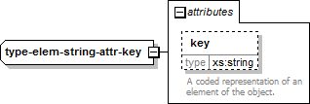
namespace | http://cnx.rice.edu/mdml
type | extension of xs:string
properties | base | xs:string
used by | element | education-levellist/education-level
attributes | Name | Type | Use | Default | Fixed | Annotation
 | key | xs:string |  |  |  | documentation A coded representation of an element of the object.
source | <xs:complexType name="type-elem-string-attr-key">  <xs:simpleContent>  <xs:extension base="xs:string">  <xs:attribute name="key" type="xs:string">  <xs:annotation>  <xs:documentation>A coded representation of an element of the object.</xs:documentation>  </xs:annotation>  </xs:attribute>  </xs:extension>  </xs:simpleContent>  </xs:complexType>

attribute type-elem-string-attr-key/@ key
type | xs:string
annotation | documentation  A coded representation of an element of the object.
source | <xs:attribute name="key" type="xs:string">  <xs:annotation>  <xs:documentation>A coded representation of an element of the object.</xs:documentation>  </xs:annotation>  </xs:attribute>

complexType type-elem-string-attr-key-qualified
diagram | 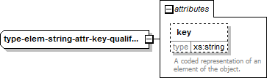
namespace | http://cnx.rice.edu/mdml
type | extension of xs:string
properties | base | xs:string
attributes | Name Type Use Default Fixed Annotation  key xs:string documentation  A coded representation of an element  of the object.
source | <xs:complexType name="type-elem-string-attr-key-qualified">  <xs:simpleContent>  <xs:extension base="xs:string">  <xs:attribute name="key" type="xs:string" form="qualified">  <xs:annotation>  <xs:documentation>A coded representation of an element of the object.</xs:documentation>  </xs:annotation>  </xs:attribute>  </xs:extension>  </xs:simpleContent>  </xs:complexType>

attribute type-elem-string-attr-key-qualified/@ key
namespace | http://cnx.rice.edu/mdml
type | xs:string
properties | form qualified
annotation | documentation  A coded representation of an element of the object.
source | <xs:attribute name="key" type="xs:string" form="qualified">  <xs:annotation>
<xs:documentation>A coded representation of an element of the object.</xs:documentation>
</xs:annotation>
</xs:attribute>

simpleType type-not-empty-positive-integer
namespace | http://cnx.rice.edu/mdml
type | restriction of xs:positiveInteger
properties | base xs:positiveInteger
facets | Kind Value Annotation  pattern [0-9]+
source | <xs:simpleType name="type-not-empty-positive-integer">  <xs:restriction base="xs:positiveInteger">  <xs:pattern value="[0-9]+"/>  </xs:restriction>  </xs:simpleType>

simpleType type-not-empty-string
namespace | http://cnx.rice.edu/mdml
type | restriction of xs:string
properties | base xs:string
facets | Kind Value Annotation  pattern .+
source | <xs:simpleType name="type-not-empty-string">  <xs:restriction base="xs:string">  <xs:pattern value=".+"/>  </xs:restriction>  </xs:simpleType>

simpleType type-string-min-lenght-one
namespace | http://cnx.rice.edu/mdml
type | restriction of xs:string
properties | base xs:string
facets | Kind Value Annotation  minLength 1
source | <xs:simpleType name="type-string-min-lenght-one">  <xs:restriction base="xs:string">  <xs:minLength value="1"/>  </xs:restriction>  </xs:simpleType>

simpleType type-string-skip-include
namespace | http://cnx.rice.edu/mdml

type | restriction of xs:string
properties | base | xs:string
facets | Kind Value Annotation enumeration skip  enumeration include
source | <xs:simpleType name="type-string-skip-include">  <xs:restriction base="xs:string">  <xs:enumeration value="skip"/>  <xs:enumeration value="include"/>  </xs:restriction>  </xs:simpleType>

complexType type-elem-string-attr-key
diagram
namespace | http://epodreczniki.pl/
type | extension of xs:string
properties | base | xs:string
attributes | Name Type Use Default Fixed Annotation  key xs:string documentation  A coded representation of an element of the object.
source | <xs:complexType name="type-elem-string-attr-key">  <xs:simpleContent>  <xs:extension base="xs:string">  <xs:attribute name="key" type="xs:string">  <xs:annotation>  <xs:documentation>A coded representation of an element of the object.</xs:documentation>  </xs:annotation>  </xs:attribute>  </xs:extension>  </xs:simpleContent>  </xs:complexType>

attribute type-elem-string-attr-key/@ key
type | xs:string
annotation | documentation  A coded representation of an element of the object.
source | <xs:attribute name="key" type="xs:string">  <xs:annotation>  <xs:documentation>A coded representation of an element of the object.</xs:documentation>  </xs:annotation>

</xs:attribute>

complexType type-elem-string-attr-key-qualified
diagram
namespace | http://epodreczniki.pl/
type | extension of xs:string
properties | base | xs:string
used by | elements |  | learning-objectives/learning-objective/learning-objective-name learning-objectives/learning-  objective/learning-objective-school learning-objectives/learning-objective/learning-objective-scope learning-objectives/learning-objective/learning-objective-stage learning-objectives/learning- objective/learning-objective-subject learning-objectives/learning-objective/learning-objective-version
attributes | Name |  | Type | Use | Default | Fixed | Annotation
 | key |  | xs:string |  |  |  | documentation A coded representation of an element of the object.
source | <xs:complexType name="type-elem-string-attr-key-qualified">  <xs:simpleContent>  <xs:extension base="xs:string">  <xs:attribute name="key" type="xs:string" form="qualified">  <xs:annotation>  <xs:documentation>A coded representation of an element of the object.</xs:documentation>  </xs:annotation>  </xs:attribute>  </xs:extension>  </xs:simpleContent>  </xs:complexType>

attribute type-elem-string-attr-key-qualified/@ key
namespace | http://epodreczniki.pl/
type | xs:string
properties | form qualified
annotation | documentation  A coded representation of an element of the object.
source | <xs:attribute name="key" type="xs:string" form="qualified">  <xs:annotation>  <xs:documentation>A coded representation of an element of the object.</xs:documentation>  </xs:annotation>  </xs:attribute>

simpleType type-not-empty-positive-integer
namespace | http://epodreczniki.pl/

type | restriction of xs:positiveInteger
properties | base xs:positiveInteger
used by | element e-textbook/volume
facets | Kind Value Annotation pattern [0-9]+
source | <xs:simpleType name="type-not-empty-positive-integer">  <xs:restriction base="xs:positiveInteger">  <xs:pattern value="[0-9]+"/>  </xs:restriction>  </xs:simpleType>

simpleType type-not-empty-string
namespace | http://epodreczniki.pl/
type | restriction of xs:string
properties | base xs:string
used by | attributes id type-link-reference/link/@ module -id type-link-reference/link/@ toc -id
facets | Kind Value Annotation  pattern .+
source | <xs:simpleType name="type-not-empty-string">  <xs:restriction base="xs:string">  <xs:pattern value=".+"/>  </xs:restriction>  </xs:simpleType>

simpleType type-string-min-lenght-one
namespace | http://epodreczniki.pl/
type | restriction of xs:string
properties | base xs:string
used by | elements e-textbook/class e-textbook/environment-type e-textbook/stylesheet
facets | Kind Value Annotation  minLength 1
source | <xs:simpleType name="type-string-min-lenght-one">  <xs:restriction base="xs:string">  <xs:minLength value="1"/>  </xs:restriction>  </xs:simpleType>

simpleType type-string-skip-include
namespace | http://epodreczniki.pl/
type | restriction of xs:string
properties | base xs:string
used by | attributes numbering toc

facets | Kind | Value | Annotation
 | enumeration | skip
 | enumeration | include
source | <xs:simpleType name="type-string-skip-include">  <xs:restriction base="xs:string">  <xs:enumeration value="skip"/>  <xs:enumeration value="include"/>  </xs:restriction>  </xs:simpleType>

